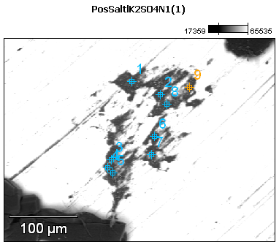

Image Name: PosSaltlK2SO4N1(1)

Image Resolution: 512 by 384

Image Pixel Size: 0.77 µm

Acc. Voltage: 12.0 kV

Magnification: 320

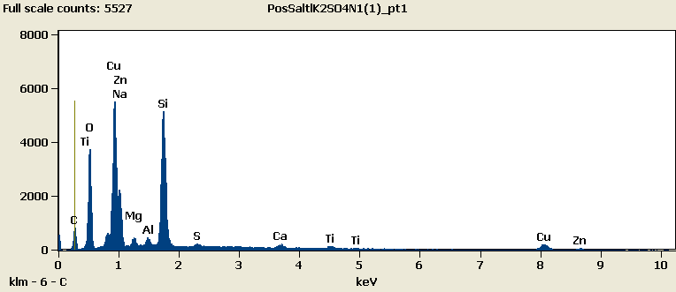

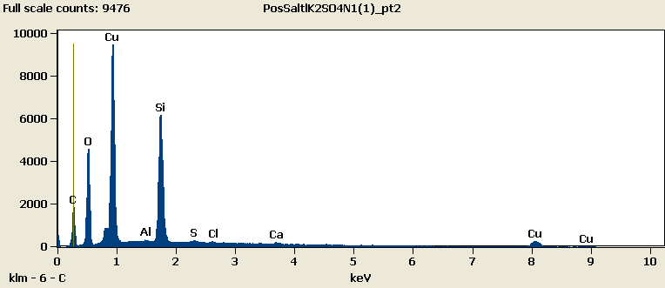

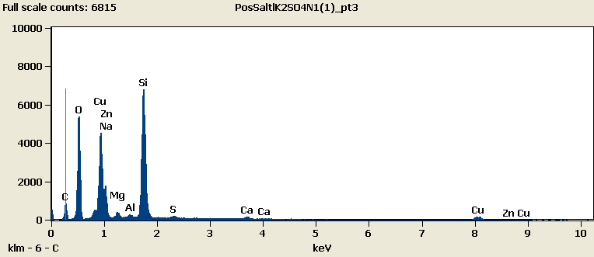

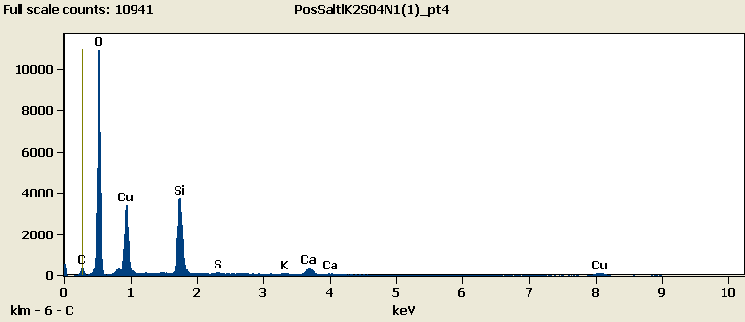

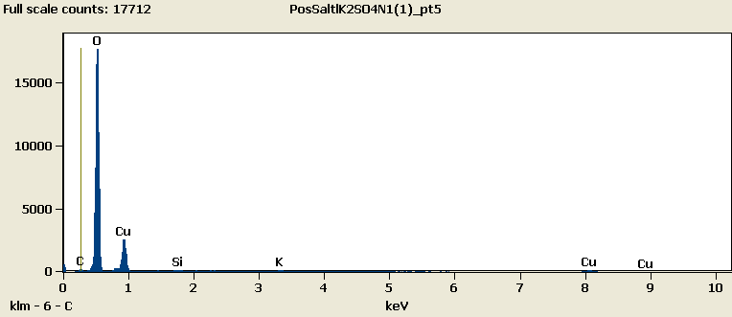

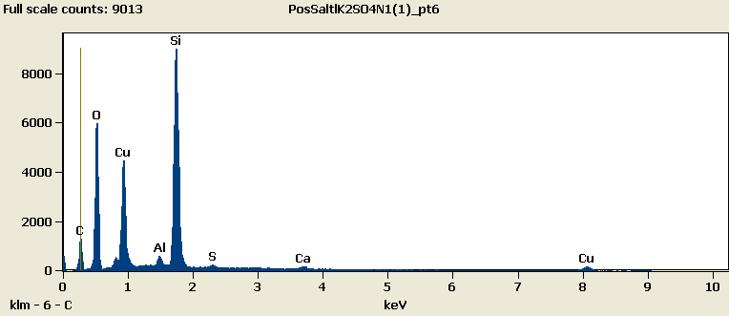

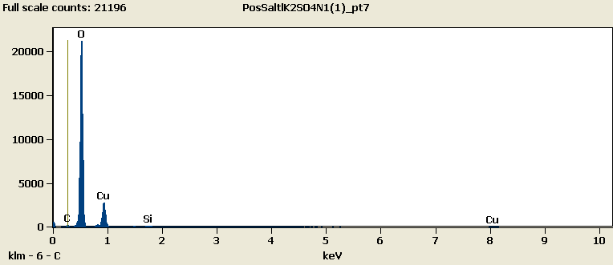

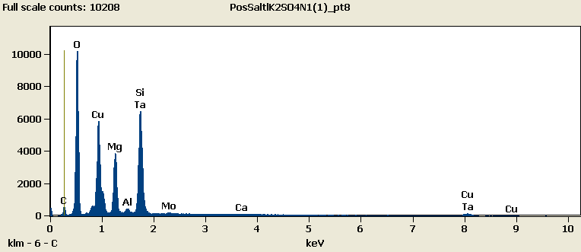

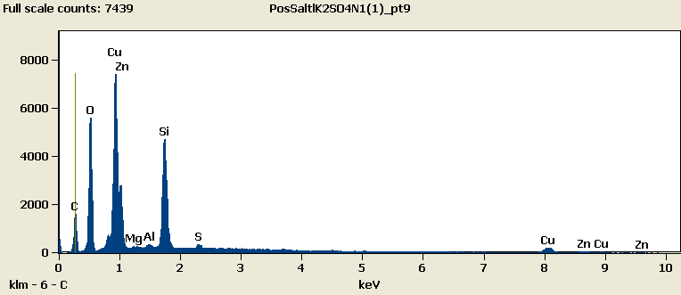

Weight %

|  |
| --- |
| ***PosSaltlK2SO4N1(1)_pt1-No Data.*** |
| ***PosSaltlK2SO4N1(1)_pt2-No Data.*** |
| ***PosSaltlK2SO4N1(1)_pt3-No Data.*** |
| ***PosSaltlK2SO4N1(1)_pt4-No Data.*** |
| ***PosSaltlK2SO4N1(1)_pt5-No Data.*** |
| ***PosSaltlK2SO4N1(1)_pt6-No Data.*** |
| ***PosSaltlK2SO4N1(1)_pt7-No Data.*** |
| ***PosSaltlK2SO4N1(1)_pt8-No Data.*** |
| ***PosSaltlK2SO4N1(1)_pt9-No Data.*** |

Weight % Error (+/- 1 Sigma)

|  |
| --- |
| ***PosSaltlK2SO4N1(1)_pt1-No Data.*** |
| ***PosSaltlK2SO4N1(1)_pt2-No Data.*** |
| ***PosSaltlK2SO4N1(1)_pt3-No Data.*** |
| ***PosSaltlK2SO4N1(1)_pt4-No Data.*** |
| ***PosSaltlK2SO4N1(1)_pt5-No Data.*** |
| ***PosSaltlK2SO4N1(1)_pt6-No Data.*** |
| ***PosSaltlK2SO4N1(1)_pt7-No Data.*** |
| ***PosSaltlK2SO4N1(1)_pt8-No Data.*** |
| ***PosSaltlK2SO4N1(1)_pt9-No Data.*** |

# Cations

|  |
| --- |
| ***PosSaltlK2SO4N1(1)_pt1-No Data.*** |
| ***PosSaltlK2SO4N1(1)_pt2-No Data.*** |
| ***PosSaltlK2SO4N1(1)_pt3-No Data.*** |
| ***PosSaltlK2SO4N1(1)_pt4-No Data.*** |
| ***PosSaltlK2SO4N1(1)_pt5-No Data.*** |
| ***PosSaltlK2SO4N1(1)_pt6-No Data.*** |
| ***PosSaltlK2SO4N1(1)_pt7-No Data.*** |
| ***PosSaltlK2SO4N1(1)_pt8-No Data.*** |
| ***PosSaltlK2SO4N1(1)_pt9-No Data.*** |